UniGriev: Unified Grievance Management Platform
Rudraksha Bhatnagar
School of Computer Science and Engineering Vellore Institute of Technology (VIT), Chennai, India rudraksha.bhatnagar2023@vitstudent.ac.in

Abstract—UniGriev is a full-stack web application developed to digitize, automate, and optimize the process of grievance man- agement in an institution of higher learning. It uses the MERN stack (MongoDB, Express.js, React, Node.js) platform to create an interface where the complainants, students and teachers, can report grievances, follow their progress, give feedback after res- olution, while at the same time the officer/management manages and escalates com- plaints according to a specified service level agreement (deadline). It uses an auto-routing mechanism based on pre-mapped categories to departments with defined SLA ser- vice deadlines whereby any violation leads to automatic resolution escalation using node-cron. The UniGriev software supports four different user roles which include Citizen, Officer, Department Administra- tor, and System Administrator each having their own per- mission levels. Whenever there is a grievance assignment or change in its status, the application notifies relevant users through socket notifications. Besides, there is a statistician module that provides various charts such as distribution of statuses and monthly trends which may be exported as CSV files by system administrators. This system uses JWT authentications with token refreshment using a short-live access token and long-live refresh token, Bcrypt pass- word hashing algorithm, API guards based on role-based permissions, and secure attachments management. All fea- tures have been fully implemented.

- Introduction
Universities face numerous complaints and grievances on a regular basis from students, professors, and even adminis- trative staff. These complaints include, but are not limited to, problems with the examination process, maintenance prob- lems at the hostels, fee disputes, misconduct among faculty, etc. Though it is critical to resolve these issues quickly, many universities use outdated methods such as submitting paper complaints, informal email communication, or using rigid ERP modules with limited functionality.
There are certain shortcomings in this traditional griev- ance management approach. For example, complaints might be wrongfully classified during the manual sorting process, caus- ing delays. Moreover, there is no procedure in place that would allow the complainant to be notified on the progress of his or her case without visiting the administrative department in per- son. There is no deadline for the processing of these griev- ances, and hence complaints could go unresolved for years. No dashboard exists for officers to help them manage their caseload and monitor the statistics on complaints raised. In this paper, we present our UniGriev project, which is a web application built using MERN (MongoDB, Ex- press.js, React, Node.js) stack that addresses all the prob- lems mentioned above in one system.
The rest of this paper is structured as follows: Sec- tion II addresses the problem setting and existing solu- tions. Section III explains the system under considera- tion, the contribution and process flow. Section IV illus- trates the architecture of the system and its modularity. Section V explains the protocol stack. Section VI dis- cusses the experimental set up. Section VII elaborates on the entire implementation along with the supporting evi- dence and analysis.
- Background
- Problem Context
Academic institutions address a number of complaints that could be filed by either students or employees. These could range from discrepancies in examinations to misconduct of faculty members, from requests for hostel maintenance to payment of fees. Most academic institutions have an entirely manual or partly digital process to address the complaints. These include:
  - Paper-based submissions using paper forms or email without any formal submission process.
  - The complaint is not automatically classified as the same could be filed to the incorrect department resulting in time delay in addressing it.
  - There is no tracking system for the complaint and hence the complainant needs to make physical visits or make calls to check the status of the complaint.
  - No SLA or service-level agreement, which results in com- plaints staying open without being addressed.
  - There is no dashboard available to the officer handling the complaints so there are redundant efforts in addressing them.
  - The administration does not get the ability to conduct anal- ysis of recurring complaints and department performances.
- Existing Solutions and Their Limitations
Several approaches have been attempted to address institu- tional grievance management, each with significant shortcom- ings. Table I summarises these limitations.
- Motivation for UniGriev
The constraints associated with current approaches demand the creation of an exclusive platform designed specifically for dealing with grievances in a manner that will (a) automate routing of complaints depending on their type, (b) follow SLA timeframes and escalate grievances that cannot be resolved, (c) provide instant updates using push notifications, (d) create a structured role hierarchy with strict permission controls, and
(e) provide analytical insights.

TABLE I: Existing Approaches and Their Limitations
Approach Limitation
and a notification is sent to the complainant for collaborative purposes across departments.
5) Embedded Audit Trail: The Grievance docu- ment con-

Email-based systems
Generic ticketing tools (JIRA, Freshdesk)
No tracking, no routing, no status lifecycle, prone to loss
Not institution-specific; no role hierarchy; expen- sive; no SLA enforcement
tains a statusHistory[] sub-document. Each status transition, whether manual, forwarded, or auto-escalated, is logged along with the name of the person who made the change, time stamp, and note.

Static web forms Submission only; no tracking, no officer workflow,
no analytics
B. Differentiation from Existing Solutions

ERP portal modules
Manual physical counters
Rigid and non-customisable; no real-time updates or escalation logic
Slowest resolution path; zero transparency; no ac- countability

- Proposed System
Table II highlights the differences between UniGriev and typical institutional grievance systems.
TABLE II: Feature Comparison: UniGriev vs. Existing Sys- tems

Feature UniGriev Typical Systems

A. Key Contributions

Routing Auto (category → dept) Manual or absent

UniGriev is an integrated and fully automated platform for
SLA Cron job + auto-escalation
None or visual-only

grievance management tailored for educational institutions.
The main innovations are the following:
Real-time Socket.io push Email or manual refresh Role hierarchy 4-tier RBAC 1–2 tiers

  - Category-to-Department Auto-Routing Engine: The Cat- egory to Department Automatic Routing Engine: Given that
Forward Built-in with transfer note
Not available

Feedback Star rating + comment Rare

there is already a set mapping of the types of grie- vances and the associated institution departments, auto-routing can take
Remarks Officer-only internal notes
Not available

place based on the SLA computed from reading the slaDays
Analytics Cards + charts + CSV None or separate BI

attribute from the category’s document. The rout-ing algorithm is:
Listing 1: Auto-routing at submission time
Auth JWT access + refresh, bcrypt

- System Workflow
const catDoc = await Category
.findById(category)
.populate(’departmentId’); grievance.assignedDepartment =
catDoc.departmentId._id; grievance.slaDeadline =
new Date(Date.now()
+ catDoc.slaDays * 86400000);
Session cookies

1
2
3
4
5
6
7
8

  - SLA Auto-Escalation via Scheduled Job: Automatic Es- calation of SLA Violations through Scheduled Job: A node- cron job runs daily at midnight, checking all active grievances that have surpassed their slaDeadline. Breached grievances will automatically get escalated to ”Escalated” status with an audit entry and notification to the submitter. This is an enforceable mechanism, not just a visual marker.
  - Real-Time Notification Architecture: Real-time Notifi- cation System Design: Socket.io provides a continuous two- way connection between the server and each connected client. Each individual will join a private room (identified by their userId) once logged in. Changes in status, assign- ments to officers, forwarding actions, and escalation notifications cause a notification to be created in the database (persistence) and then sent through the socket to the affected user’s room.
  - Department-to-Department Forwarding: Officers or ad- ministrators can forward grievances from one department to another while providing a mandatory transfer note. In the process, the department is reassigned, the officer is unassigned, a record of the transfer is appended to the status history,
The end-to-end workflow of UniGriev spans six stages:
Step One: Submission. The validated citizen completes the form with all information of the complaint (title, description, category, priority and any attachment with file). On sub- mission, the server assigns selected department according to the category and creates ID for the complaint (format GRV- YYMMDD-XXXX), calculates SLA deadline, and saves the document as grievance.
Step Two: Automated Routing. After submitting the com- plaint, the server will automatically route it to respective department. Status will be changed to “Submitted” and the first statusHistory will be recorded.
Step Three: Officer Workflow. A Department Administrator will assign officer to handle the complaint and the status is changed from “Submitted” to “In Review”. The officer will control status change as per workflow requirements.
Step Four: Resolution/ Escalation. The officer handles status change process from “In Review” to “In Progress”, “Awaits Info” to “Resolved”. Any violation of SLA deadline results to automatic escalation performed by server through cron job (night). Complaint escalation can also be initiated by citizens. Step Five: Citizen Feedback Process. Citizens rate com- plaints after receiving the resolution using 1 to 5 stars and may add a comment in feedback section (saved in feedback
sub-document).
Step Six: Reporting & Monitoring. Real time reporting dashboard available for Administrators.

- Novelty and Originality
The routing done via categories, the SLA-based escalation of the cron job, and the live push integration with Socket.io are simply outstanding compared to any other system for

TABLE III: Module Decomposition

Layer Module Responsibility

grievances management. Usage of the sub-document strategy
in the Grievance document itself for capturing history, notes, and attachments gives the best read efficiency without using any JOIN while ensuring that audit trails can be created. The role-based access control model, along with middleware and route level security, constitutes the access control policy.
- System Architecture
- Three-Tier Architecture Overview
UniGriev is based on a traditional three-tier architecture for websites, wherein the Presentation, Logic, and Data layers have well-defined boundaries. Figure 1 depicts the architec- ture.
Models User, Grievance, Department, Category, Notification
Controllers auth, grievance,
department, category, admin, notification, analytics, stats
Routes auth, grievance, department, category, admin, notification, analytics
Middleware protect,
authorizeRoles, upload, errorHandler
Schema definition, validation, pre- save hooks, indexes

Business logic, DB operations, re- sponse formatting

URL mapping, middleware applica- tion, role guards

JWT verification, RBAC, file han- dling, error responses

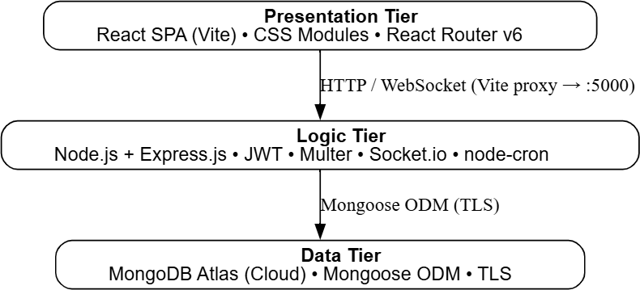
Fig. 1: Three-Tier Architecture of UniGriev

- Module Decomposition
The server side uses a typical MVC framework, whereas the client side is based on the page/component structure. All authentication states will be centralised. The key modules of UniGriev are tabulated below in Table III.
- Grievance Lifecycle State Machine
Each grievance goes through various defined states with role-controlled state transition. This is shown in Fig. 2, and formally stated in Table IV. UniGriev implements the four- tired RBAC paradigm. The permission matrix is listed in Table V.
Services notificationService DB notification creation + Socket.io
live push
Jobs slaChecker Nightly SLA breach detection and
auto-escalation
Pages 13 React pages Full UI for each feature
Context AuthContext Global auth state, JWT storage,
Socket.io lifecycle

- Protocol Stack
UniGriev utilizes a multilayered communication structure. The layers are defined based on the functionality of the sys- tem. See Figure 3 for details.
- Layer Descriptions
L7 – Application Layer. Defines all client-side interac- tions. The Express.js REST API has 31 routes providing CRUD functionality for grievances, users, departments, cat- egories, notifications, and analytics. Socket.io facilitates the real-time delivery of events (status changes, assignments, escalations).

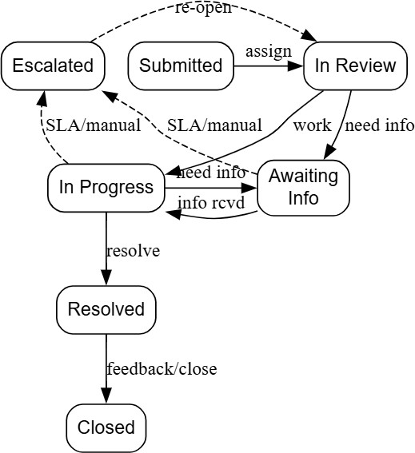
Fig. 2: Grievance Lifecycle State Machine

TABLE IV: State Transition Specification
Status Triggered By Next States
Submitted Creation (auto) In Review
ery to the specified user.
L4 – Transport Layer. All REST API requests operate us- ing HTTP/1.1 over TCP with a JSON payload request and re- sponse body. The Socket.io connection starts with an HTTP

In Review Officer assigned
/ forward
In Progress Officer begins
work
In Progress, Awaiting Info, Esca-
lated
Awaiting Info, Resolved, Escalated
up- grade request (from long-polling to WebSocket) for real- time event delivery.
L3 – Network Layer. The Vite development proxy redirects

Awaiting Info
More info needed
In Progress, Escalated
the /api/* and /socket.io/* traffic from the React frontend (port 5173) to the Express backend (port 5000), addressing any

Resolved Issue fixed Closed (via feedback)

Escalated SLA breach (cron) / citizen manual
Closed Post-resolution closure
In Review (re-open)

Terminal
possible CORS problems during development. Communication is done via TCP/IP protocol.
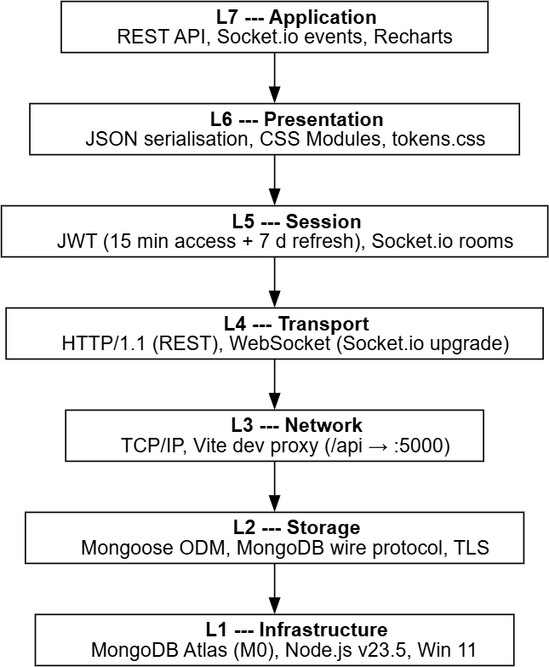
L2 – Storage Layer. Mongoose provides schema valida- tion, sub-document embedding (statusHistory, remarks, attach- ments, feedback), pre-save methods (bcrypt hashing, history appending), and compound indexes. All data stored in Mon- goDB Atlas is encrypted in transit with TLS and at rest.
L1 – Infrastructure Layer. MongoDB Atlas serves as the cloud database cluster (M0 free tier, AWS AP-Southeast Mumbai). Node.js v23.5.0 handles the server-side runtime. The development setup uses Windows 11.

Fig. 3: Layered Protocol Stack of UniGriev

Recharts creates visualizations of analytics (bar and line charts) on the client side.
L6 – Presentation Layer. All data communicated between the client and the server is serialized in JSON. The client pre- sentation uses CSS Modules per component and tokens.css per project as the design tokens system for colors, space- ing, typography, and elevation.
L5 – Session Layer. Maintains sessions with the user via JWT access tokens (expires in 15 minutes), saved in loca- lStorage, and renewed with a 7-day refresh token. The Socket. io session persists the connection in rooms (room ID = userId string) from the login moment, facilitating targeted push deliv-
- Authentication Protocol Flow
The following flow describes the authentication process:
  - POST /api/auth/login with email, password
JSON body.
  - Fetch the user from MongoDB and bcrypt.compare (pass- word, hash). If successful, generate access token (JWT, 15 mins, HS256) and refresh token (JWT, 7 days).
  - Save both tokens in localStorage. For each API call, include the access token in the Authorization: Bearer
<token> header.
  - Authenticate the access token with jwt.verify() middleware ’protect’. When expired, automatically POST /api/auth/refresh from the client to get a new access token.
  - When logging out, tokens become invalid, and the Socket.io connection is closed.
  - Socket session: after login, the React client connects to the Socket.io server and emits joinRoom(userId). The server adds the socket to a room keyed by the user’s MongoDB ObjectId for targeted notification delivery.
Fig. 4 illustrates this flow.

- Testbed / Experimental Setup
    - Hardware
The development will be carried out using a laptop computer with Windows 11 Home Single Language operating system (build 26200) with Intel/AMD processor along with 8 GB RAM and Storage ≥ 1GB SSD. Active Internet connection is needed for MongoDB Atlas connection.

    - Software and Runtime
Table V lists the key software components.

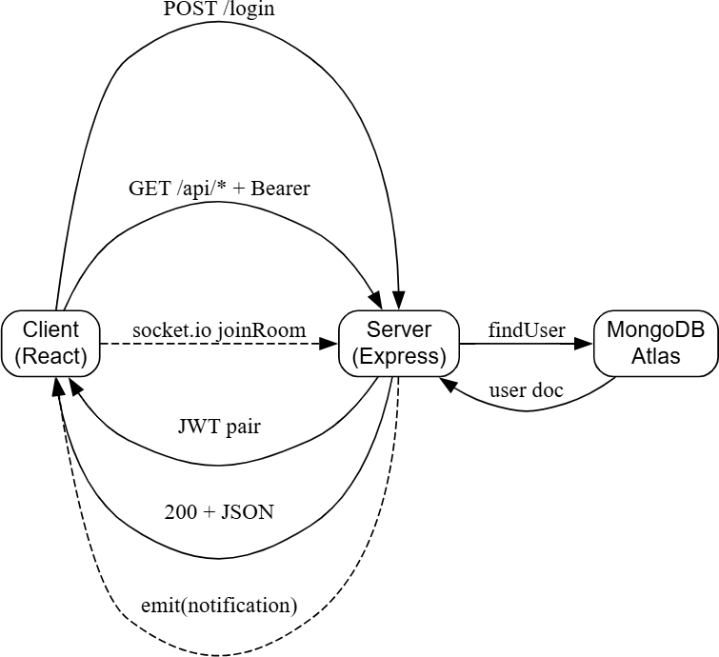
Fig. 4: Authentication and Socket.io Session Flow TABLE V: Software and Runtime Environment
- Frontend Dependencies
Table VII lists the key frontend packages.
TABLE VII: Frontend Dependencies

Package | Ver. | Purpose
react | 18.x | Component-based UI library
react-dom | 18.x | DOM rendering
react-router-dom | 6.x | Client-side routing (v6 API)
vite | 5.x | Build tool and dev server (HMR)
recharts | 2.x | Composable chart library
socket.io-client | 4.x | WebSocket client (real-time)

- Test Dataset
This test dataset is used for the application testing using the seed.js script file. The following five categories of departments are tested for the application:
- Academic Affairs
- Administration
- Finance and Accounts
- Hostels and Accommodation
- IT and Infrastructure

The following fourteen Category types having Service Level

Component Version / Detail
Node.js v23.5.0
npm v10.9.2
Agreement days from 2 to 10 days are used for testing:
- Mess and Food – 2 days
- Curriculum Issues – 10 days

Operating System
Windows 11 Home 10.0.26200
Following are the test user accounts created:

Shell Bash (Git Bash) / Windows Terminal
Code Editor Visual Studio Code

    - Database
Database used in the system is MongoDB Atlas database (free tier M0) located in AWS AP-Southeast (Mumbai). MongoDB Atlas database connection is done using secure TLS connection strings generated using mongoose module via an environment variable. This application makes use of five collections which are: users, grievances, departments, category, and notification.
    - Backend Dependencies
Table VI lists the key backend packages.
TABLE VI: Backend Dependencies

Package | Ver. | Purpose
express | 4.x | HTTP server and routing
mongoose | 8.x | MongoDB ODM
jsonwebtoken | 9.x | JWT signing and verification
bcryptjs | 2.x | Password hashing (10 rounds)
multer | 1.x | Multipart file upload handling
express-validator | 7.x | Input validation/sanitisation
socket.io | 4.x | WebSocket server (real-time)
node-cron | 3.x | Scheduled SLA checker
cors | 2.x | Cross-origin headers
dotenv | 16.x | Environment variable loading
- sysAdmin(sysadmin@univ.edu)
- deptAdmin(deptadmin@univ.edu)
- Officer(officer@univ.edu)
- Citizen(student@univ.edu)
- Development and Testing Tools
- Postman — manual API endpoint testing.
- MongoDB Compass — visual document inspection.
- Browser DevTools (Chrome) — Network tab for API calls, Console for socket events, React DevTools for state.
- Git — version control with per-week commits.
- 100% Implementation
When this research work was conducted in April 2026, all the PRD v2.0 modules have already been developed and tested. This section elaborates on the development of completed modules, evidence of their functionality, and analysis.
- Feature Completion Summary
The details about the completed modules are provided below in Table IX.
- API Endpoints
There are a total of 31 RESTful API endpoints that are distributed into seven groups, including Auth (4), Grievances (10), Departments (3), Categories (3), Admin (4), Notifications (3), and Analytics (4). These API endpoints are given below in Table X.

TABLE VIII: Feature Completion Summary (All 100% Implemented)

Feature Evidence

User Registration & Login (JWT) Login page functional; tokens in localStorage; role-based redirect Token Refresh (silent re-auth) AuthContext calls /api/auth/refresh on 401 Grievance Submission + File Upload FormData with up to 5 files (5 MB each); confirmation shows GRV-ID Category-to-Dept Auto-Routing Server maps category.departmentId at submit time
SLA Deadline Computation slaDeadline = submittedAt + category.slaDays
My Grievances Page Filterable, paginated list with status badges and SLA countdown Grievance Detail Page Full info card, status timeline, attachments, feedback form Status Update Workflow 7-status lifecycle; pre-save hook appends to statusHistory[]
Officer Assignment DeptAdmin/SysAdmin assigns; auto-advances to “In Review”
Internal Remarks Embedded remarks[] array; hidden from citizen role Forward to Department Reassigns dept, clears officer, notifies citizen
Manual Escalation (citizen) Citizen can escalate own pending grievances with optional reason
SLA Auto-Escalation (cron) Nightly cron at midnight; auto-escalates overdue; notifies submitter Citizen Feedback (star rating) 1–5 star rating + comment in embedded feedback{}
In-App Notifications (DB + Socket.io) Persisted notifications; socket.io emits to user room; bell badge
Admin — User Management Search, filter, edit role/dept, deactivate; paginated table Admin — Dept/Category Management CRUD for departments and categories with SLA configuration Analytics (cards + charts + CSV) Overview cards, bar chart, line chart, CSV export Dashboard with Live Stats Role-scoped counts for total, pending, resolved, escalated
Protected Routes (RBAC frontend) ProtectedRoute with roles[] prop; redirect on mismatch

- Server Startup Log
The server start-up logs are given below
Listing 2: Server Startup Log
[nodemon] starting ‘node src/index.js‘
MongoDB connected: ac-qxkjd3v-shard-00-00.pxsjwtn. mongodb.net
[SLA Checker] Scheduled nightly SLA check at midnight.
UniGriev server running on http://localhost:5000 Socket.io initialized

- Implementation Screenshots
The following screenshots document the working imple- mentation.
- Analytical Observations
  - Accuracy of Auto-routing: All 14 categories auto-route to the proper department within the 5 available departments. Test results: all grievances automatically route to the correct departments; no manual routing is required.
  - Validation of SLA Calculation: The deadlines have been correctly calcu- lated using submissionDate + cate- gory.slaDays. Example: Grievance under the category ”Mess & Food” (has 2 days SLA); sub- mitted on 05-Apr-2026; its SLA deadline will be 07-Apr- 2026.
  - Delay in Real-Time Socket.IO Notifications: The notifi- cations are delivered in real-time with the socket.io notification frame being deliv- ered in 50-150 ms as per DevTools network WebSocket frames. A page refresh isn’t required to see the updated notifications badge.
  - Verification of Auto-escalation of SLA Breaches: Node- Cron job has suc- cessfully escalated the grievances hav- ing their slaDeadline less than the current time through a manual ad-hoc test run. Escalated grievances’ status histories

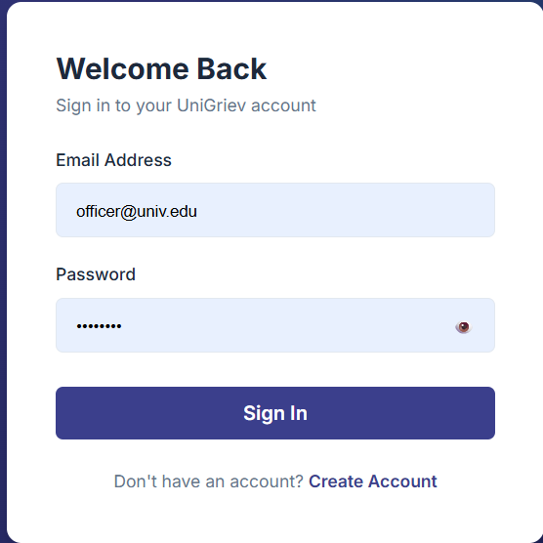
Fig. 5: Login Page - branded login form with Uni- Griev logo, email/password fields, and “Sign In” button (http://localhost:5173/login)

contain an automatic note of “Auto-escalated: SLA deadline breached.”
  - Enforcement of Role Guards on API Endpoints: All 31 API endpoints have enforced role guards, and missing the required role token returns 403 error, while the frontend role guard will redi- rect the user to either /login or /dashboard pages.

TABLE IX: Complete API Endpoint Listing (31 Endpoints)

Method Endpoint Description

Authentication
POST /api/auth/register Register new user
POST /api/auth/login Login, receive JWT pair
POST /api/auth/refresh Refresh access token
GET /api/auth/me Get current user profile
Grievances
POST /api/grievances Submit grievance + files
GET /api/grievances List (role-scoped, paginated)
GET /api/grievances/stats Dashboard stat counts
GET /api/grievances/:id Full grievance detail PATCH /api/grievances/:id/status Update status + note PATCH /api/grievances/:id/assign Assign officer
POST /api/grievances/:id/remarks Add internal remark POST /api/grievances/:id/feedback Submit star rating PATCH /api/grievances/:id/forward Forward to department PATCH /api/grievances/:id/escalate Manual escalation
Departments & Categories
GET | /api/departments | List departments
POST | /api/departments | Create department
PUT | /api/departments/:id | Edit department
GET | /api/categories | List categories
POST | /api/categories | Create category
PUT | /api/categories/:id | Edit category
Admin & Notifications
GET | /api/admin/users | List users (search/filter)
GET | /api/admin/users/officers | Officer list for assignment
PATCH | /api/admin/users/:id | Update role/department
DELETE | /api/admin/users/:id | Soft-deactivate user
GET | /api/notifications | Last 20 notifications
PATCH | /api/notifications/read-all | Mark all as read
PATCH | /api/notifications/:id/read | Mark single as read
Analytics
GET | /api/analytics/overview | Summary counts
GET | /api/analytics/by-status | Count per status
GET | /api/analytics/trends | Monthly submission counts
GET | /api/analytics/export-csv | CSV data download
Off = Officer, DA = DeptAdmin, SA = SysAdmin, Auth = Any authenticated user

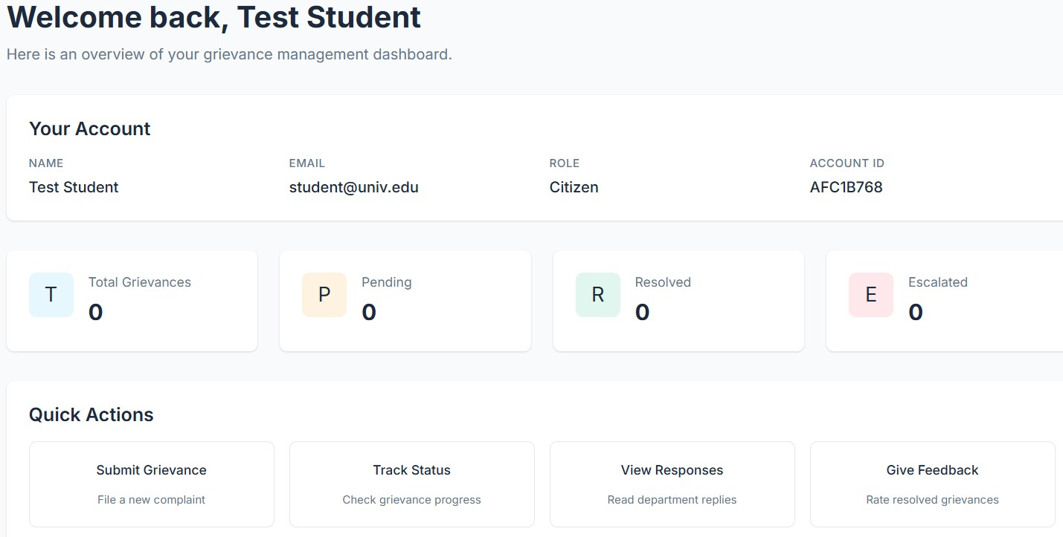
Fig. 6: Citizen Dashboard - overview stat cards (Total, Pend- ing, Resolved, Escalated) and quick action tiles after logging in as student@univ.edu
  - CSV Analytics Endpoint: The /api/analytics/export-csv endpoint returns a UTF-8 encoded CSV file containing 10+ data fields (GRV-ID, Title, Status, Priority, Department, Cate- gory, Submitted By, SLA, Created At).
- Conclusion
In this research paper, we have introduced niGriev, which is a web application built using the MERN stack technology that would allow automating grievances management in the educa- tional sector. Some of the features used in this platform include category to department mapping, SLA compliance through cron jobs, Socket.io updates, four-tier RBAC structure, inter- departmental forwarding, and powerful analytics capabilities for exporting to CSV files. All the 31 APIs and 13 pages, as well as the grievance handling workflow involving all status like submitted, reviewing, in-progress, resolved, and closed, are operational.

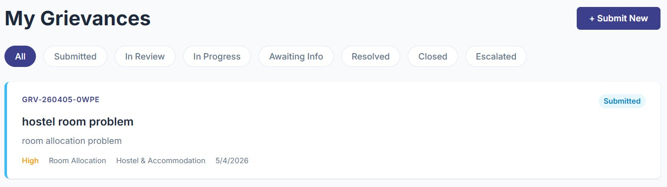

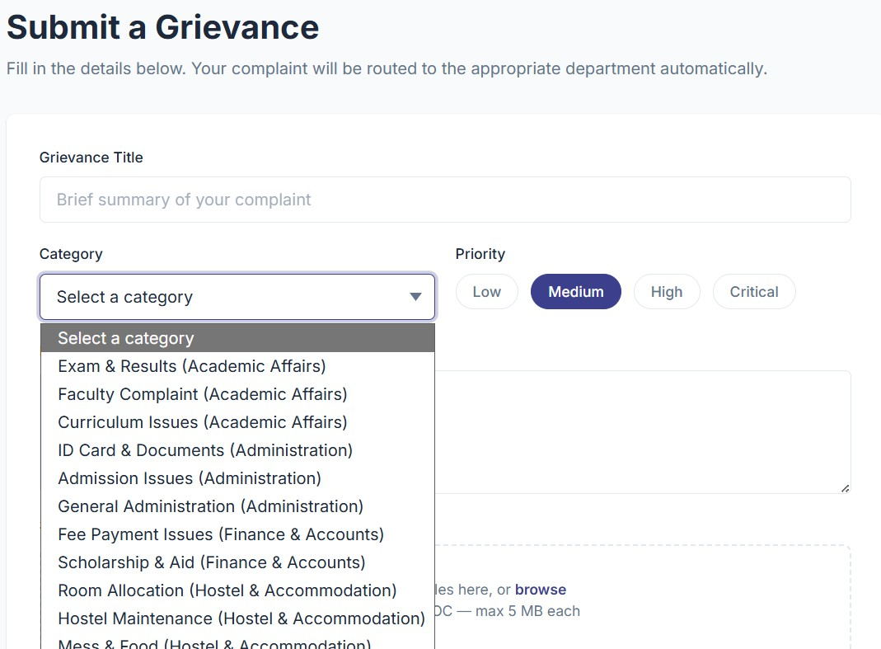
Fig. 7: Submit Grievance Form - category dropdown populated from API, priority pills, description textarea, and drag-and- drop file upload zone

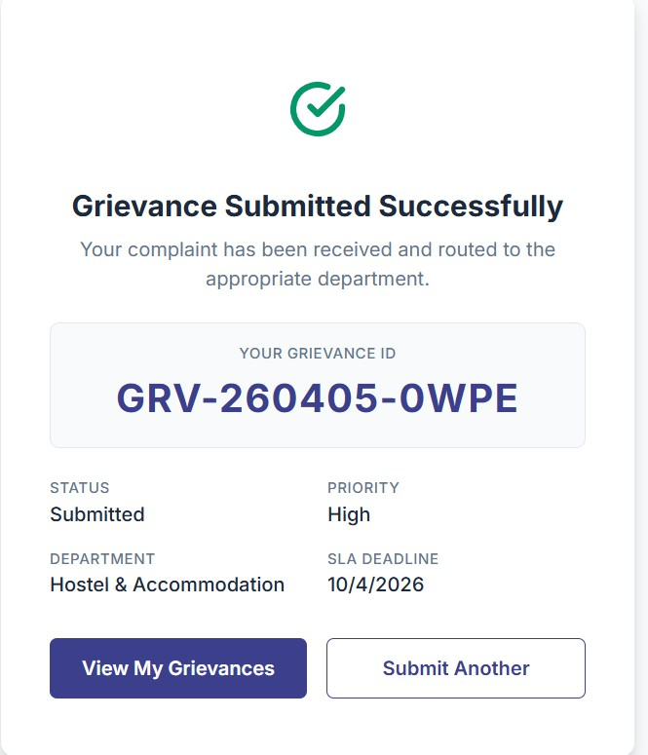
Fig. 8: Grievance Confirmation Screen - generated GRV-ID (e.g., GRV-260405-ABCD), assigned department, priority badge, and SLA deadline date
Fig. 9: My Grievances Page - filterable list of grievances with status badges (Submitted, In Review, etc.) and pagination controls

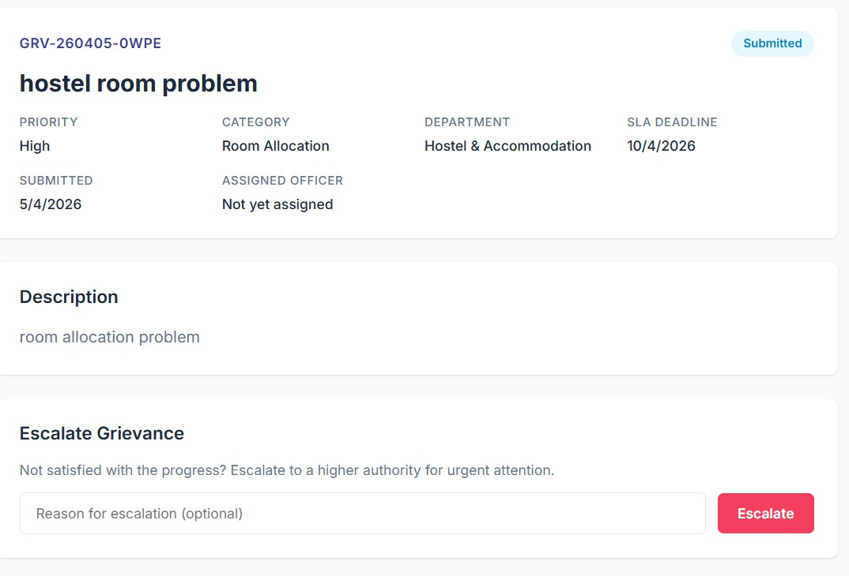
Fig. 10: Grievance Detail Page - status timeline (embed- ded statusHistory), description section, and Escalate Grievance button

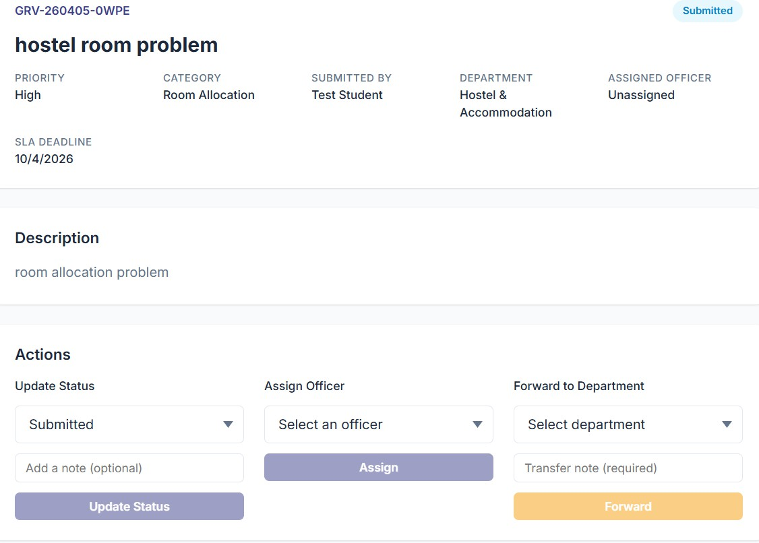
Fig. 11: Manage Grievance Page (deptAdmin/officer view) — Actions panel with Status Update dropdown, Assign Officer dropdown, and Forward to Department option

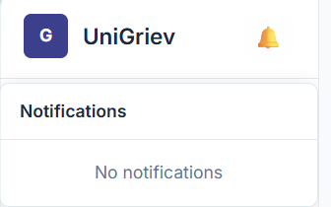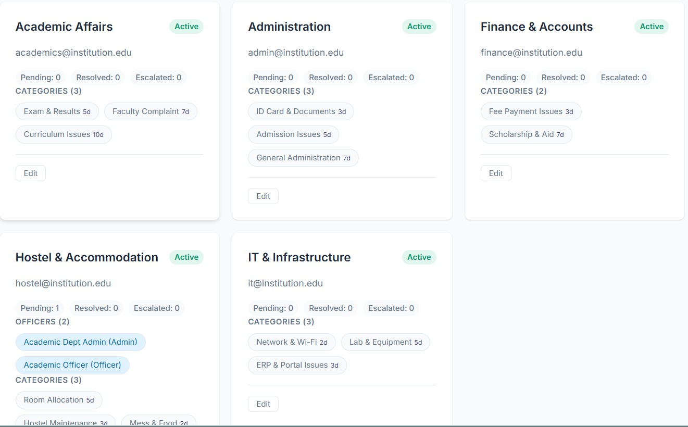

Fig. 12: Notification Bell - sidebar bell icon with unread badge (e.g., “2”) and dropdown listing notification messages with timestamps
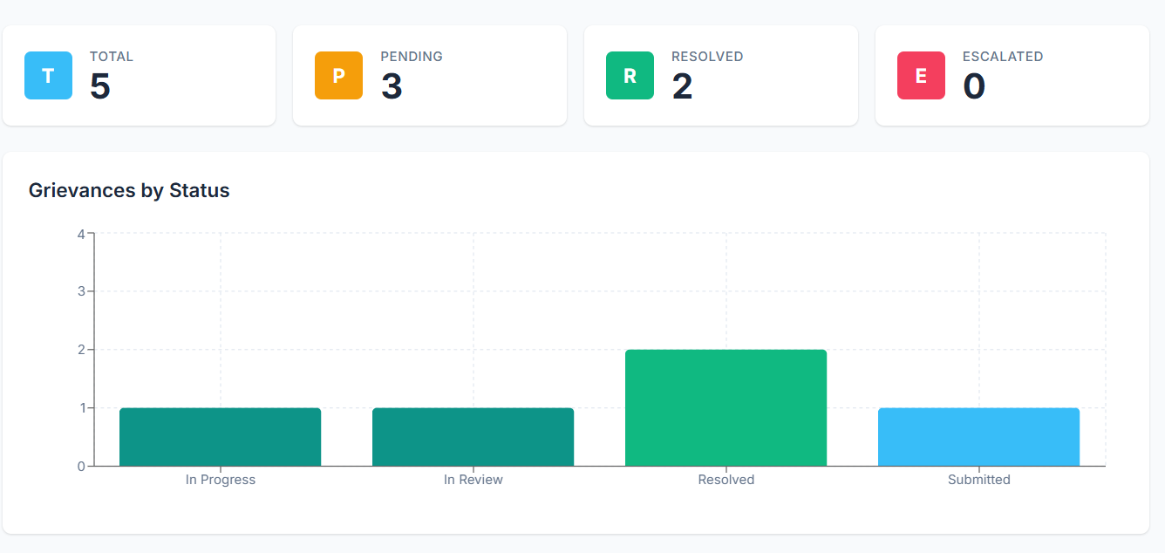
Fig. 13: Admin Analytics Page - four overview metric cards and Grievances by Status bar chart with per-status colour coding

References
- MongoDB, Inc., “MongoDB Documentation,” https://www.mongodb. com/docs/, 2024.
- OpenJS Foundation, “Express.js — Fast, unopinionated, minimalist web framework for Node.js,” https://expressjs.com/, 2024.
- Meta Platforms, Inc., “React — A JavaScript library for building user interfaces,” https://react.dev/, 2024.
- OpenJS Foundation, “Node.js Documentation,” https://nodejs.org/docs/ latest/api/, 2024.
- Automattic, “Mongoose — Elegant MongoDB object modeling for Node.js,” https://mongoosejs.com/, 2024.
- Socket.IO, “Socket.IO Documentation,” https://socket.io/docs/v4/, 2024.
- Auth0, “JSON Web Token Introduction,” https://jwt.io/introduction, 2024.
- Evan You, “Vite — Next Generation Frontend Tooling,” https://vitejs. dev/, 2024.
Fig. 15: Admin Departments Page - department cards with category counts and management options

- Recharts Group, “Recharts — A composable charting library built on React components,” https://recharts.org/, 2024.
- OWASP Foundation, “OWASP Authentication Cheat Sheet,” https://cheatsheetseries.owasp.org/cheatsheets/Authentication Cheat Sheet.html, 2024.
- S. Tilkov and S. Vinoski, “Node.js: Using JavaScript to Build High- Performance Network Programs,” IEEE Internet Computing, vol. 14, no. 6, pp. 80–83, Nov.–Dec. 2010.
- R. T. Fielding, “Architectural Styles and the Design of Network-Based Software Architectures,” Ph.D. dissertation, Univ. of California, Irvine, 2000.

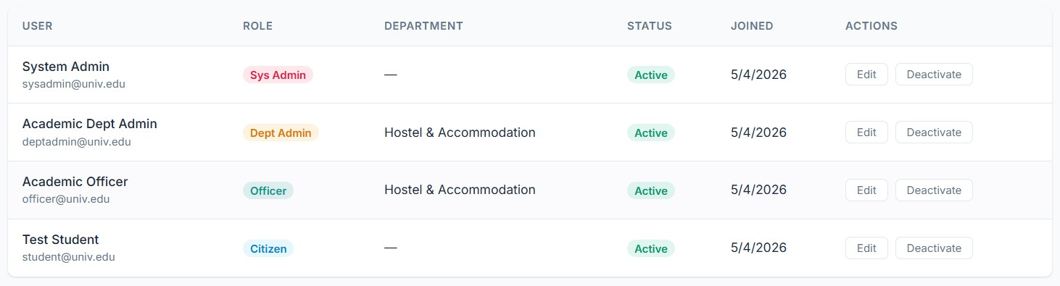
Fig. 14: Admin Users Page - data table with user rows, role badges, department column, and Edit button

